Web Development Task 3 – Mariah Zahra

1a.Technical Document:

|  |  |  |  |  |  |
| --- | --- | --- | --- | --- | --- |
| Test | Expected Result | Actual Result | Pass / Fail | Notes | Github Id. |
| User Browsing Website | Being able to scroll through the products | Users are able to scroll through the products | Pass |  | d95e6a9 |
| Hover selection of Product | Users should be able to hover over the product | Users are able to hoever over the products | Pass | When working on the website i saw that there was no need for a cart | d95e6a9 |
| Adding products to cart | User should be able to put products into cart | User cannot put products into cart | Fail | When working on the website i saw that there was no need for a cart | d95e6a9 |
| Removing product from cart | User should be able to remove products from cart | User cannot remove the products from cart | Fail |  | d95e6a9 |
| Specific product | User should be able to see the products they want | Users are able to see the specific product they want | Pass |  | d95e6a9 |
| Register | User should be able to register an account | User cannot register an account | Fail | When working on the website i saw that there was no need for a register | d95e6a9 |
| Log-in | User should be able to log-in to an exisiting account | User cannot log-in into an exsisting account | Fail | When working on the website I saw that there was no need for a log-in | d95e6a9 |
| Buttons hover | User should be able to hover over the buttons | Users are able to hover over the buttons and the buttons change | Pass |  | d95e6a9 |
| Zoom in on products when hovred over them | when hovering over the product, they should zoom in | Products when hoevered over work and zoom into the prouct | Pass |  | d95e6a9 |
| Contact us section | Users should be able to type in their information | Users are able to type in their informtion in the selected box | Pass |  | d95e6a9 |
| Quick links | Each link should be able to go to a specific part of the page | Users are able to access sections of the website through the quick links | Pass |  | d95e6a9 |
| Carousel | Carousel should be working when pressing the arrows | Users are able to press on the arrows and scroll through the carousel | Pass |  | d95e6a9 |

2. Validation of Code:

a. using the link to be able to validate the code:

b. when pressing on the link it takes you to the website to be able to validate your code:

c. after file has been chosen to check, a list of errors pops up to validate:

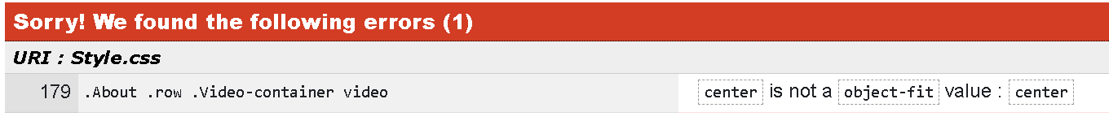

d. review each error to fiix in the website.

3. I think that the main issues with my website are mostly related to the log-in and register functionality and adding and removing items from the cart. I considered including these features, but during development, I decided they weren’t necessary. The primary concept was to allow the user to access the website without the need for a log in or register process, aiming for a seamless and accessible experience. However, when coming to reflect on this, i realize that incorporating a cart section would have enhanced user interaction. By adding and removing items from the cart is fundamental aspect of an engaging and functional e-commerce site.

If i had the opposrtunity to redesign or improve the website, i would definitley prioritize adding these features. A well-implemented login system could provide personalized experiences, such as saving user preferences and order functionality not only simplifies the purchasing process but aslo adds to the over all usability and interactivity of the site.

However, I am genuinly pleased with how my website turned out. It meets its primary goals and serves its intended purpose effectively. I love the overall website design, as well as the nevigation and the content, both being engaging. While there is always room for improvement, I am proud of the final product and the effort that went into it. 😊